A PROJECT REPORT

**Healthcare Insurance Claims Analysis**



Submitted by

ADITYA VERMA (22BCA10953)

In partial fulfilment for the award of the degree of

BACHELOR OF COMPUTER APPLICATION

IN

UNIVERSITY INSTITUTE OF COMPUTING

CHANDIGHARD UNIVERSITY

APRIL 2025

**Abstract**

Healthcare insurance claims analysis plays a critical role in improving operational efficiency, detecting fraudulent activities, and enhancing patient care within the insurance sector.

This study aims to analyze large volumes of health insurance claims data to uncover patterns, trends, and anomalies that can inform decision-making.

Using statistical methods and data visualization techniques, key performance indicators such as claim frequency, cost per claim, approval rates, and processing time were examined.

The analysis also highlights common causes of claim rejections and delays. Insights derived from this study can assist insurers in streamlining the claims process, identifying high-risk claims, and optimizing resource allocation.

Furthermore, the findings can support healthcare providers in improving service delivery and ensuring better compliance with insurance policies.

The study demonstrates the value of data-driven approaches in managing healthcare costs and improving transparency in the insurance claim lifecycle.

**Acknowledgement**

I would like to express my sincere gratitude to everyone who contributed to the successful completion of this project on Healthcare Insurance Claims Analysis.

Their expertise and encouragement helped me stay focused and motivated.

I am also grateful for providing the resources and infrastructure necessary to carry out this analysis, including access to relevant data and tools.

A special thanks goes to my peers and colleagues for their continuous support, discussions, and suggestions, which enriched the quality of this project.

Finally, I would like to acknowledge the support of my family and friends, whose encouragement and understanding made this work possible.

**Table of Content**

1. INTRODUCTION
2. NEED AND USES
3. DATA (MS EXCEL SHEET)
4. CHART
5. FUTURE WORK

**Introduction**

Healthcare insurance claims analysis is a vital process in the modern healthcare and insurance industries. It involves examining claim data to uncover patterns, assess performance, detect fraud, and ensure accurate and timely reimbursements. As healthcare costs continue to rise and claim volumes increase, insurance providers face growing pressure to optimize operations and improve decision-making.

This analysis helps insurers evaluate the efficiency of claim processing, identify frequently occurring issues such as delays or denials, and monitor claim trends across different demographics and medical services. It also provides insights that can lead to better policy design, improved customer satisfaction, and reduced financial risks.

In this project, we aim to analyze healthcare insurance claims data to extract meaningful insights related to claim frequency, cost distribution, approval rates, and potential anomalies. By leveraging data analysis techniques, we hope to support insurance providers and healthcare organizations in enhancing their processes and making informed, data-driven decisions.

**Need and Use**

**Need for Claims Analysis**

The healthcare industry generates massive amounts of data through insurance claims. Analyzing this data has become essential for several reasons:

1. Rising Healthcare Costs  
   With increasing medical expenses and a growing number of policyholders, it is crucial for insurance companies to monitor and control claim-related costs effectively.
2. Fraud Detection and Risk Management  
   Insurance fraud is a major concern that leads to significant financial losses. Claims analysis helps detect suspicious patterns and anomalies that may indicate fraudulent activity.
3. Operational Efficiency  
   Delays and errors in claim processing can lead to customer dissatisfaction and regulatory issues. Analyzing claims helps identify bottlenecks and inefficiencies in the workflow.

**Uses of Claims Analysis**

Healthcare insurance claims analysis has multiple practical applications across various departments:

1. Cost Analysis and Forecasting  
   Helps in understanding where most healthcare spending occurs and allows forecasting of future claim costs.
2. Policy Optimization  
   Assists in evaluating the effectiveness of insurance plans and refining coverage options based on real-world usage.
3. Customer Insights  
   Provides valuable information about customer behavior, frequently used services, and satisfaction levels.
4. Fraud Prevention  
   Identifies irregular patterns that may indicate false claims or overbilling by providers.

**DATA (MS EXCEL SHEET)**

**Overview**

Microsoft Excel is a powerful and accessible tool for analyzing healthcare insurance claims, especially when advanced analytics platforms are not available. It allows users to organize, clean, visualize, and interpret large volumes of claims data using built-in functions, pivot tables, charts, and formulas.

This analysis helps insurance providers, healthcare organizations, and analysts gain insights into cost trends, claim frequency, denial reasons, and overall performance—leading to improved efficiency, reduced fraud, and better policy decisions.

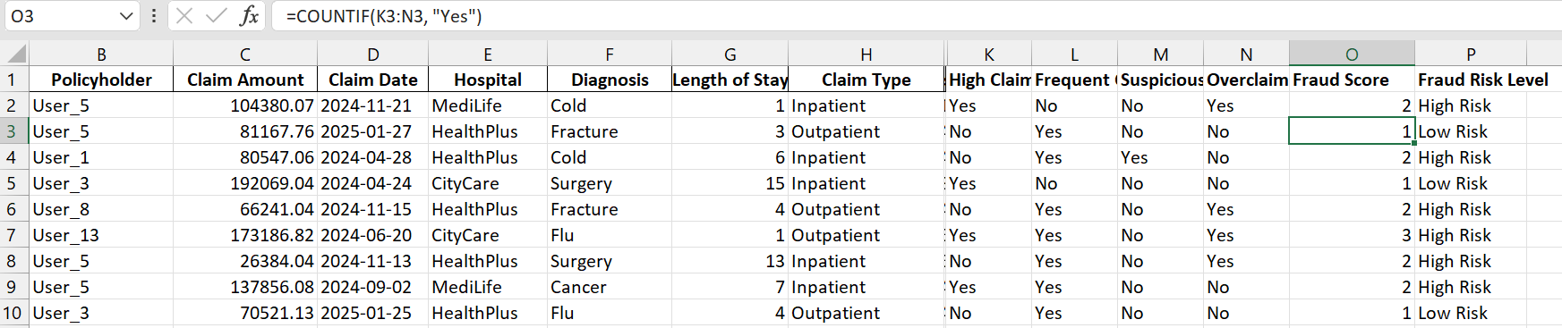

**CHART FOR THE EXCEL DATA**

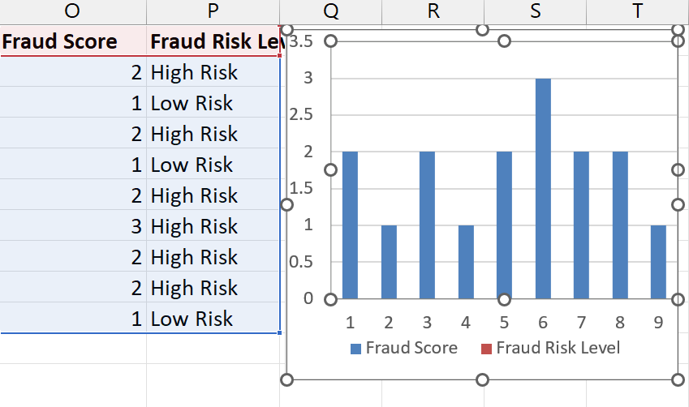

**FUTURE WORK**

**1. Integration with Advanced Tools**

Future analysis can benefit from integration with advanced analytics platforms such as **Power BI**, **Tableau**, **SQL**, or **Python** to handle larger datasets, perform predictive analytics, and build dynamic dashboards.

**2. Implementation of Machine Learning Models**

Machine learning algorithms can be applied to:

* Predict claim approvals or denials
* Detect fraudulent claims more accurately
* Classify claims based on risk or priority This would require access to historical labeled data and tools beyond Excel, such as Python with Scikit-learn or TensorFlow.

**3. Real-Time Data Analysis**

Currently, claims analysis is retrospective. A future improvement would be to implement **real-time or near real-time analytics** using live data feeds, helping insurance companies act quickly on anomalies or trends.

**4. Enhanced Fraud Detection**

Future work can explore more sophisticated fraud detection models using anomaly detection, pattern recognition, and clustering techniques, which go beyond rule-based or manual checks.

**5. Inclusion of Unstructured Data**

Expanding the analysis to include **unstructured data** such as doctors' notes, scanned documents, and patient feedback can provide a more holistic view. Natural Language Processing (NLP) techniques could be used for text analysis.

**6. Automation and Workflow Optimization**

Automating repetitive tasks like data cleaning, report generation, and claim classification can significantly reduce manual effort and improve turnaround time. Tools like **Power Automate**, **Macros**, or **VBA** in Excel could be used initially.